STUDENT PERFORMANCE SQL TRACKER
Abstract / Introduction
This project analyzes student performance using SQL. The dataset contains student details, subject
marks, and attendance
Objective of the Project
The objective of this project is to store and analyze student performance data using SQL queries to
extract meaningful insights
Dataset Description
The dataset includes 200 students with fields: Student ID, Name, Gender, Class, Attendance,
Subject marks, Total Marks, and Average Marks
Tools & Methodology
Tools: Online SQL Editor (sqliteonline.com).
Methodology:
1. Import dataset
2. Create table
3. Insert data
4. Execute SQL queries

SQL Queries with Explanation and Output (description of results)
Selects:
- Show all student records: SELECT * FROM students; Retrieves all data

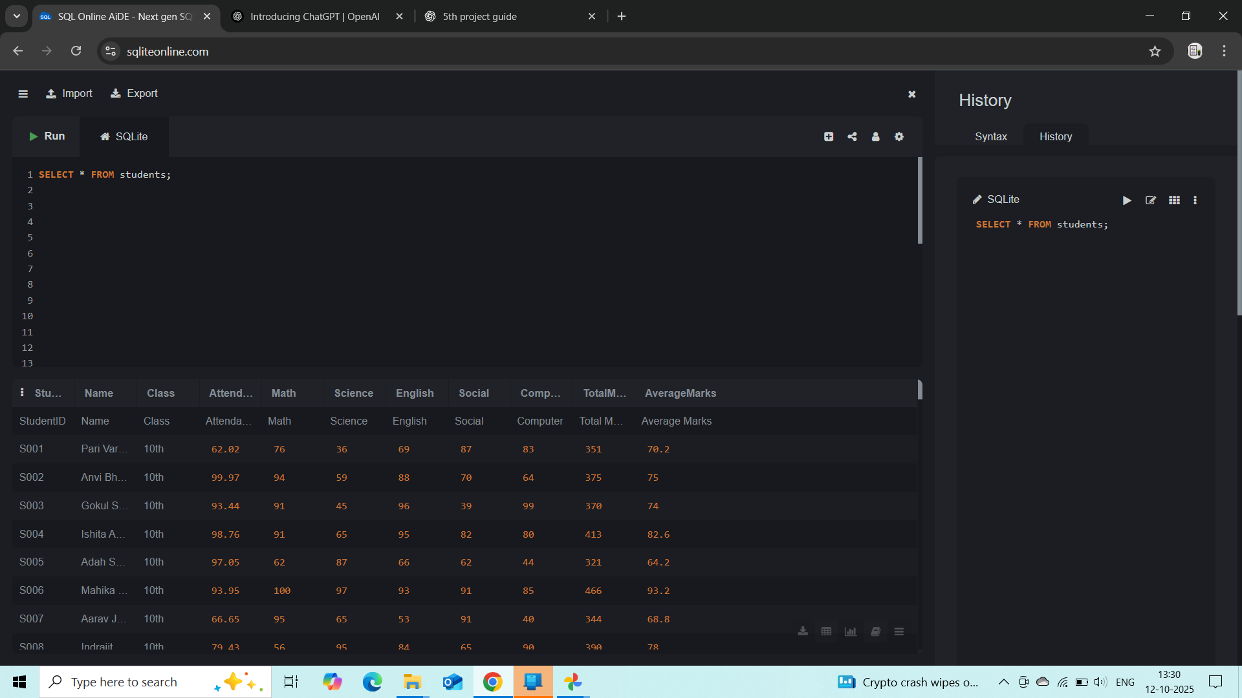

- Top 5 students by Total Marks:
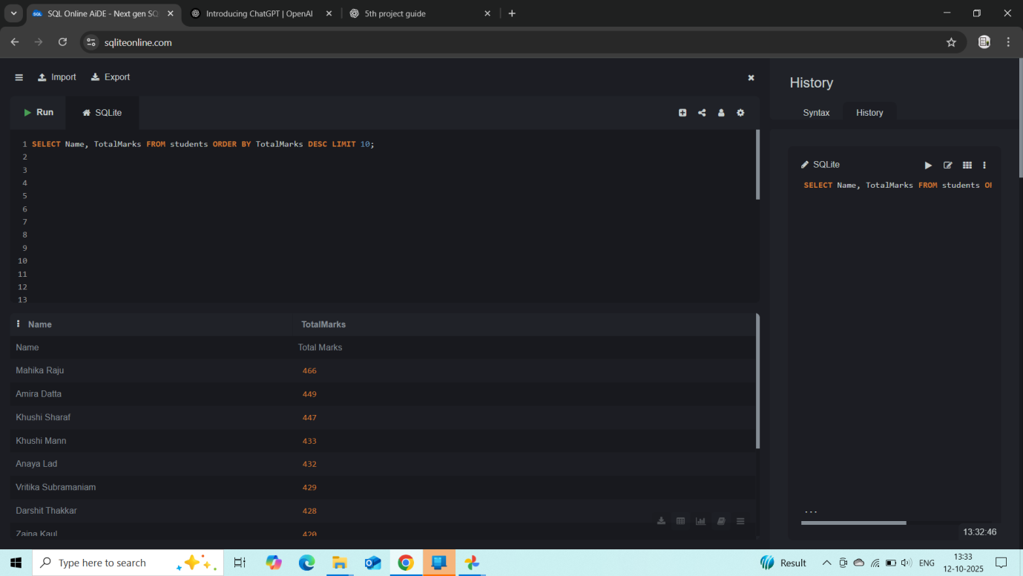

SELECT Name, Total Marks FROM students ORDER BY Total Marks DESC LIMIT 10.

- Subject-wise toppers: Example (Math):

SELECT Name, Math FROM students ORDER BY Math DESC LIMIT 5.

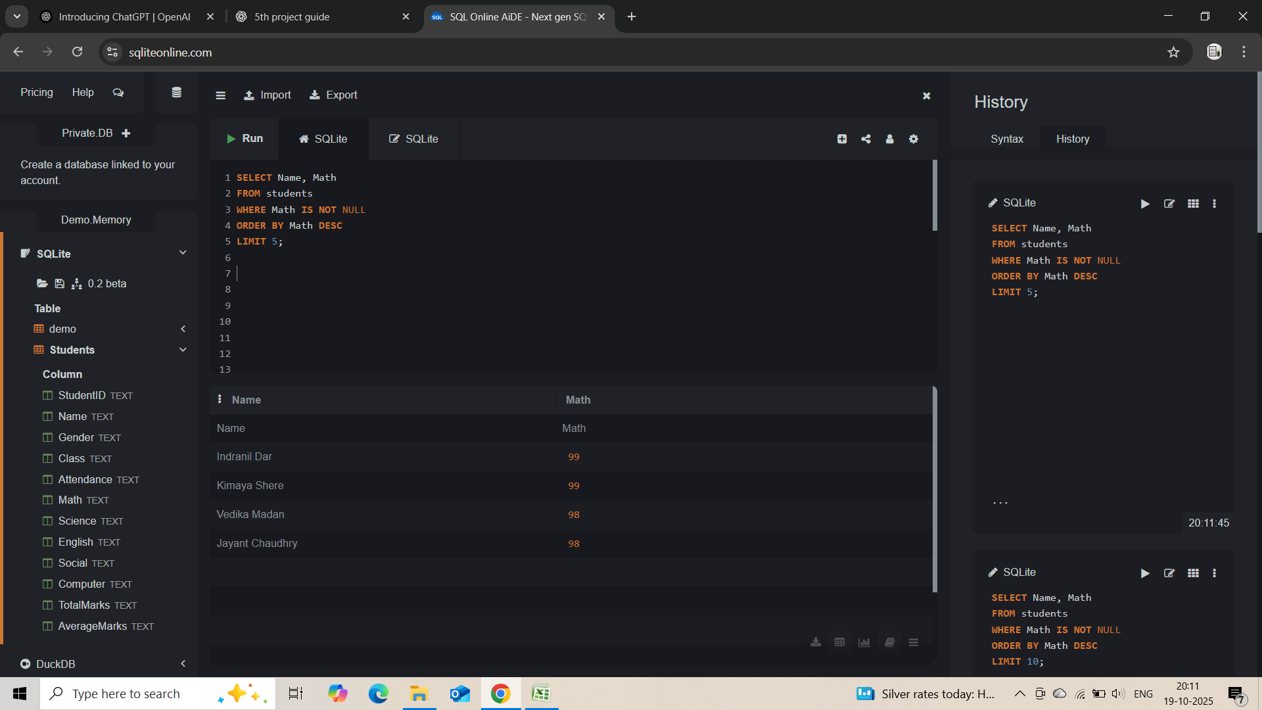
- Average marks of each subject:
SELECT AVG (Math), AVG (Science), AVG (English), AVG (Social), AVG (Computer) FROM
Students.
Gives class average per subject.
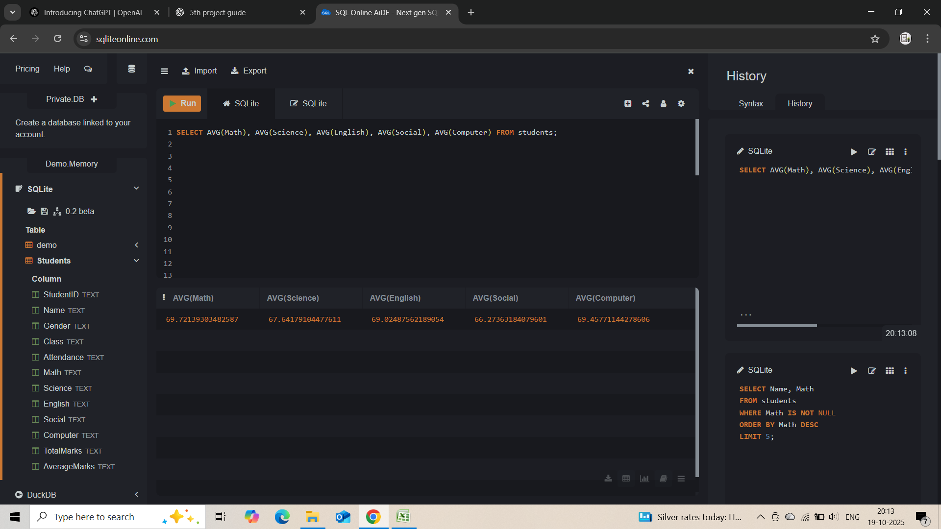

5.Students who failed any subject (<35):
SELECT *FROM students WHERE Math < 35 OR Science < 35 OR English < 35 OR Social < 35 OR Computer < 35.
Lists weak students.

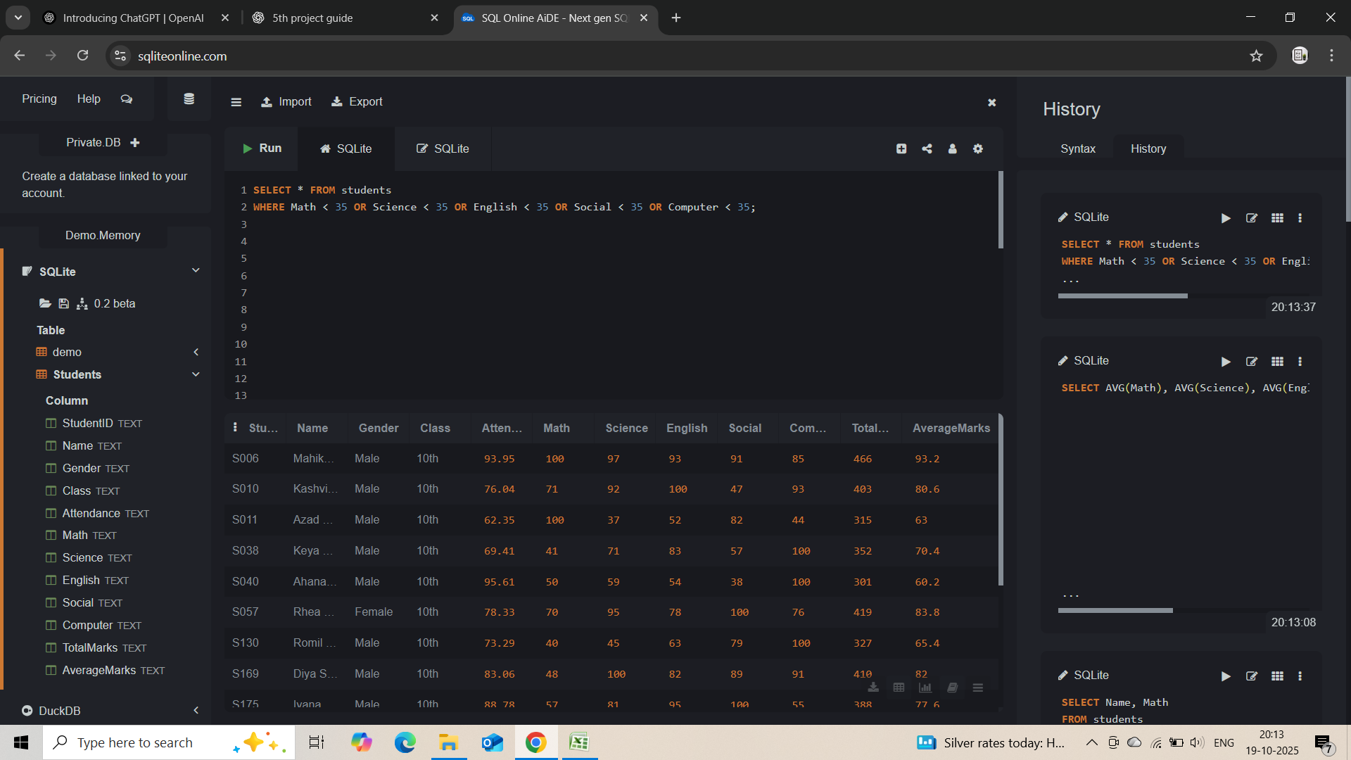
- Students with attendance < 75%:
SELECT Name Attendance FROM students WHERE Attendance < 75.
Shows low attendance.

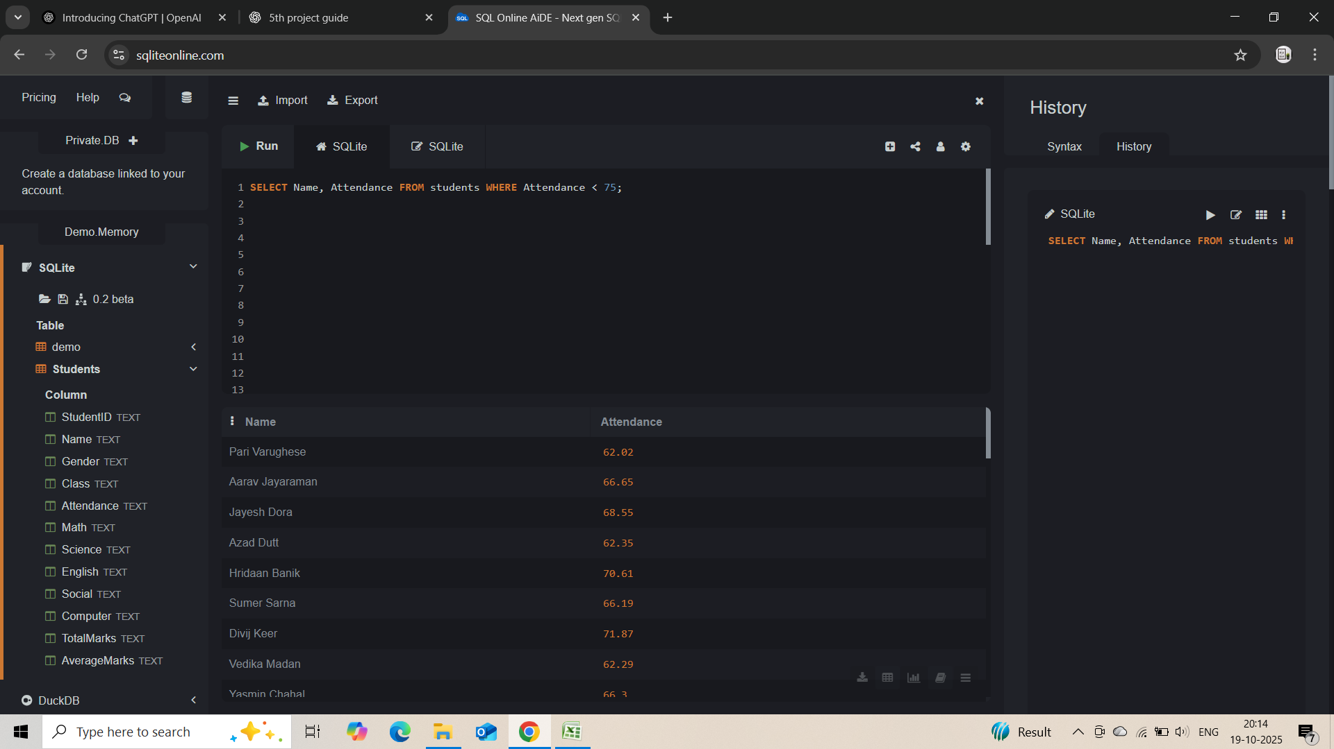

- Highest attendance student:
SELECT Name, Attendance FROM students ORDER BY Attendance DESC LIMIT 8;
Most punctual student.

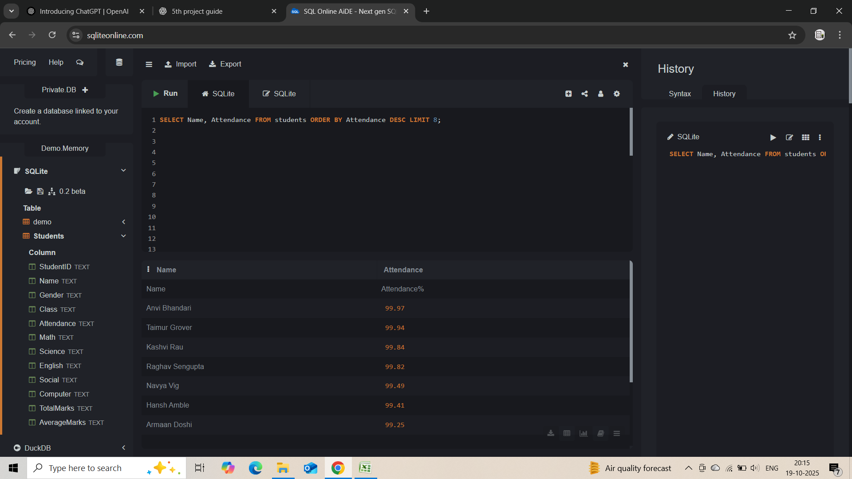
- Class performance (Average of Average Marks):
SELECT AVG(Average Marks) FROM students;
Shows overall class performance.

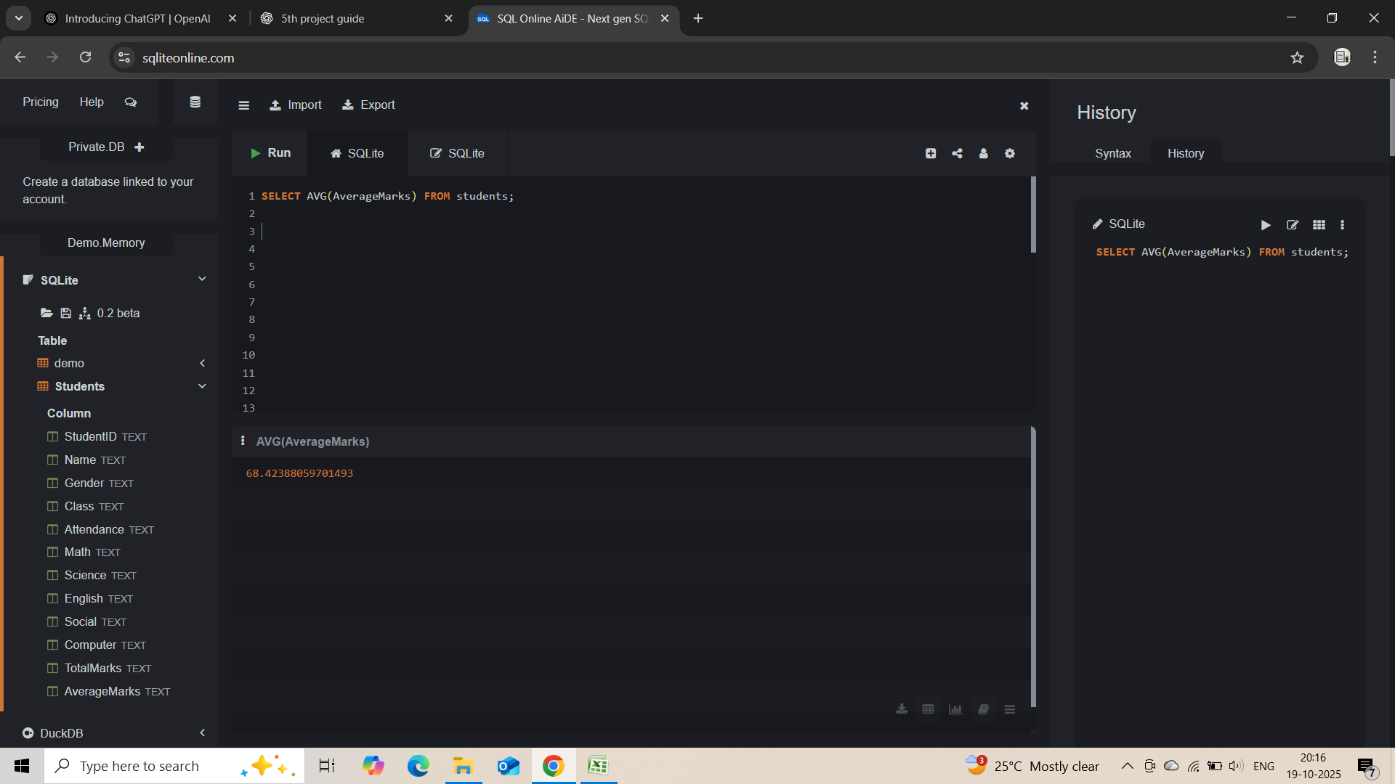

Aggregations:

1 . COUNT:
Total number of students:
SELECT COUNT(*) AS Total_Students FROM students

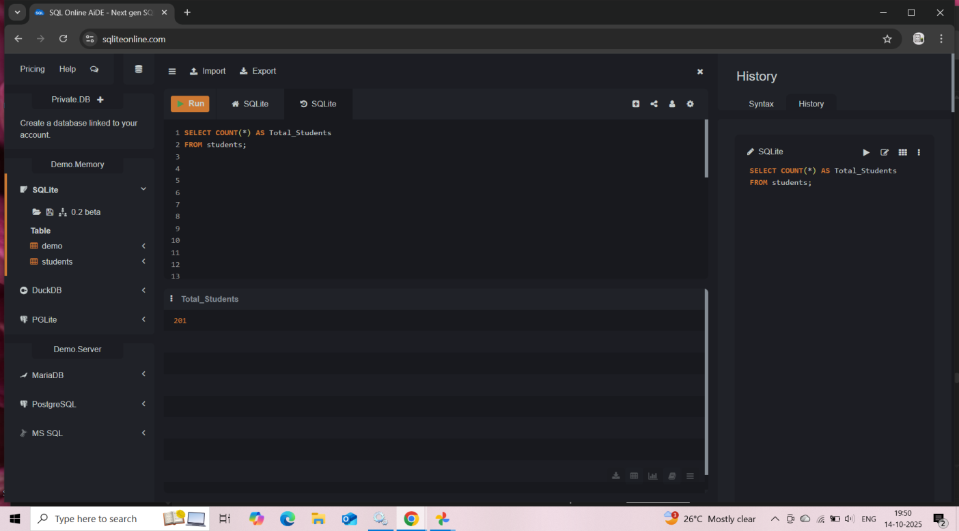
2.SUM:
Total of all Math marks:
SELECT SUM(Math) AS Total_Math_Marks FROM students;

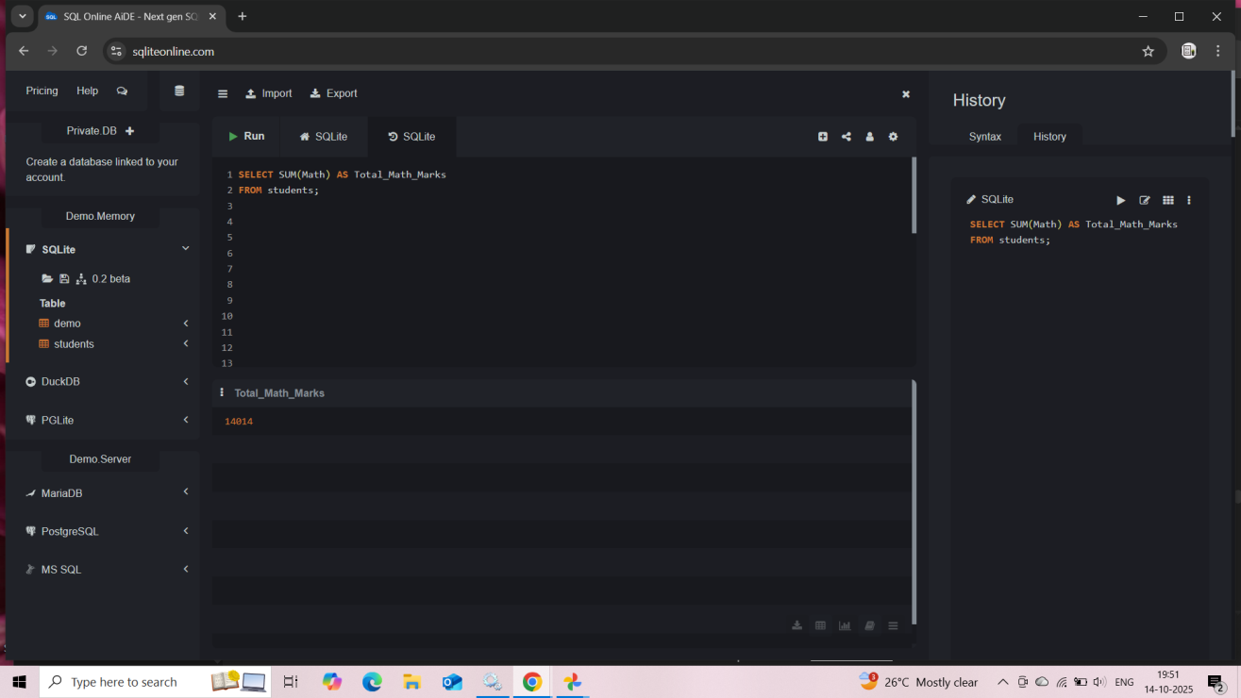

3. AVERAGE:
Average marks of each subject:
SELECT
AVG(Math) AS Avg_Math,
AVG(Science) AS Avg_Science,
AVG(English) AS Avg_English,
AVG(Social) AS Avg_Social,
AVG(computer) AS Avg_Computer
FROM students;

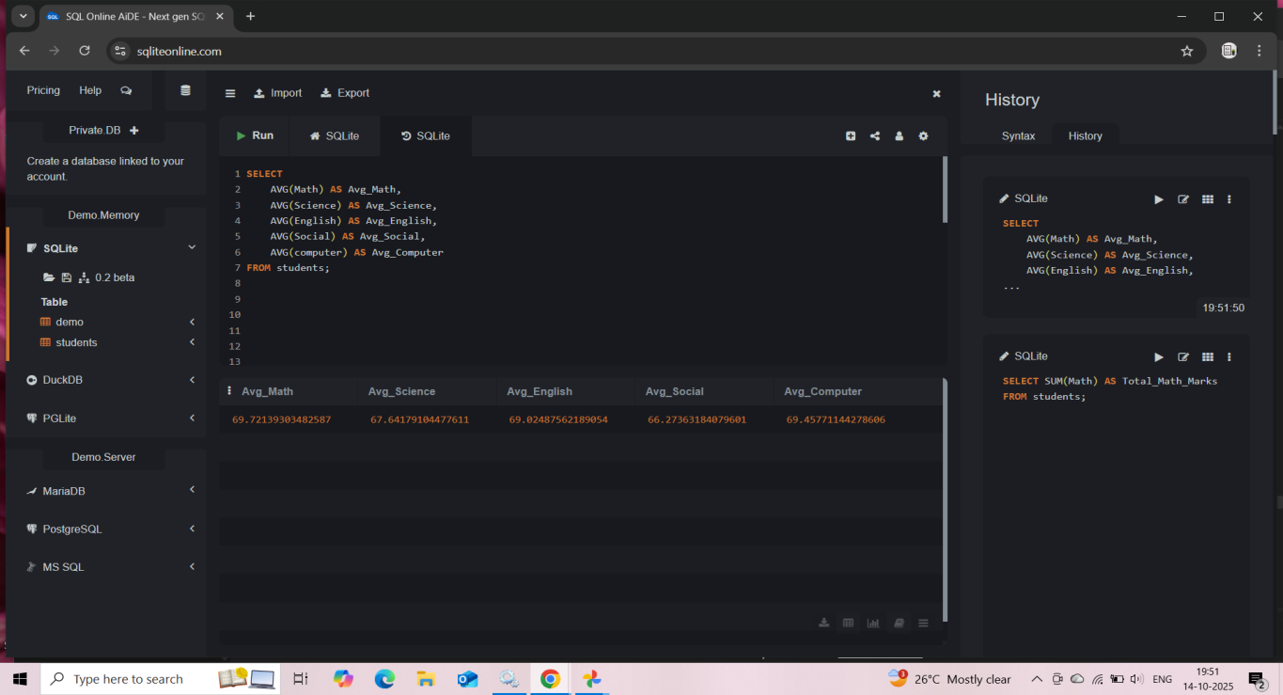
4 . MINIMUM:
Lowest marks in each subject:
SELECT
MIN(Math) AS Lowest_Math,
MIN(Science) AS Lowest_Science,
MIN(English) AS Lowest_English,
MIN(Social) AS Lowest_Social,
MIN(computer) AS Lowest_Computer
FROM students:

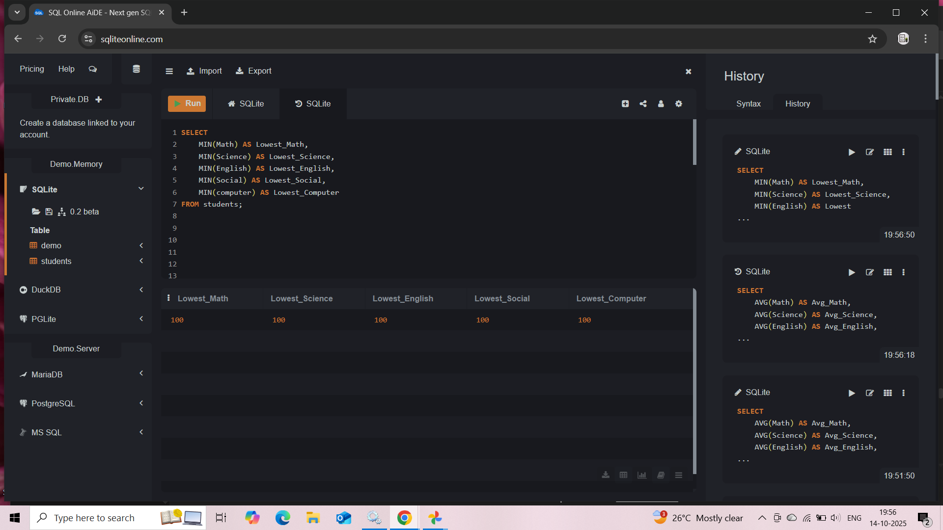

- GROUP BY + COUNT:
How many students in each attendance range:

SELECT
CASE
WHEN Attendance >= 90 THEN '90-100%'
WHEN Attendance >= 80 THEN '80-89%'
WHEN Attendance >= 70 THEN '70-79%'
ELSE '<70%'
END AS Attendance_Range,
COUNT(*) AS Student_Count
FROM students
GROUP BY Attendance_Range;

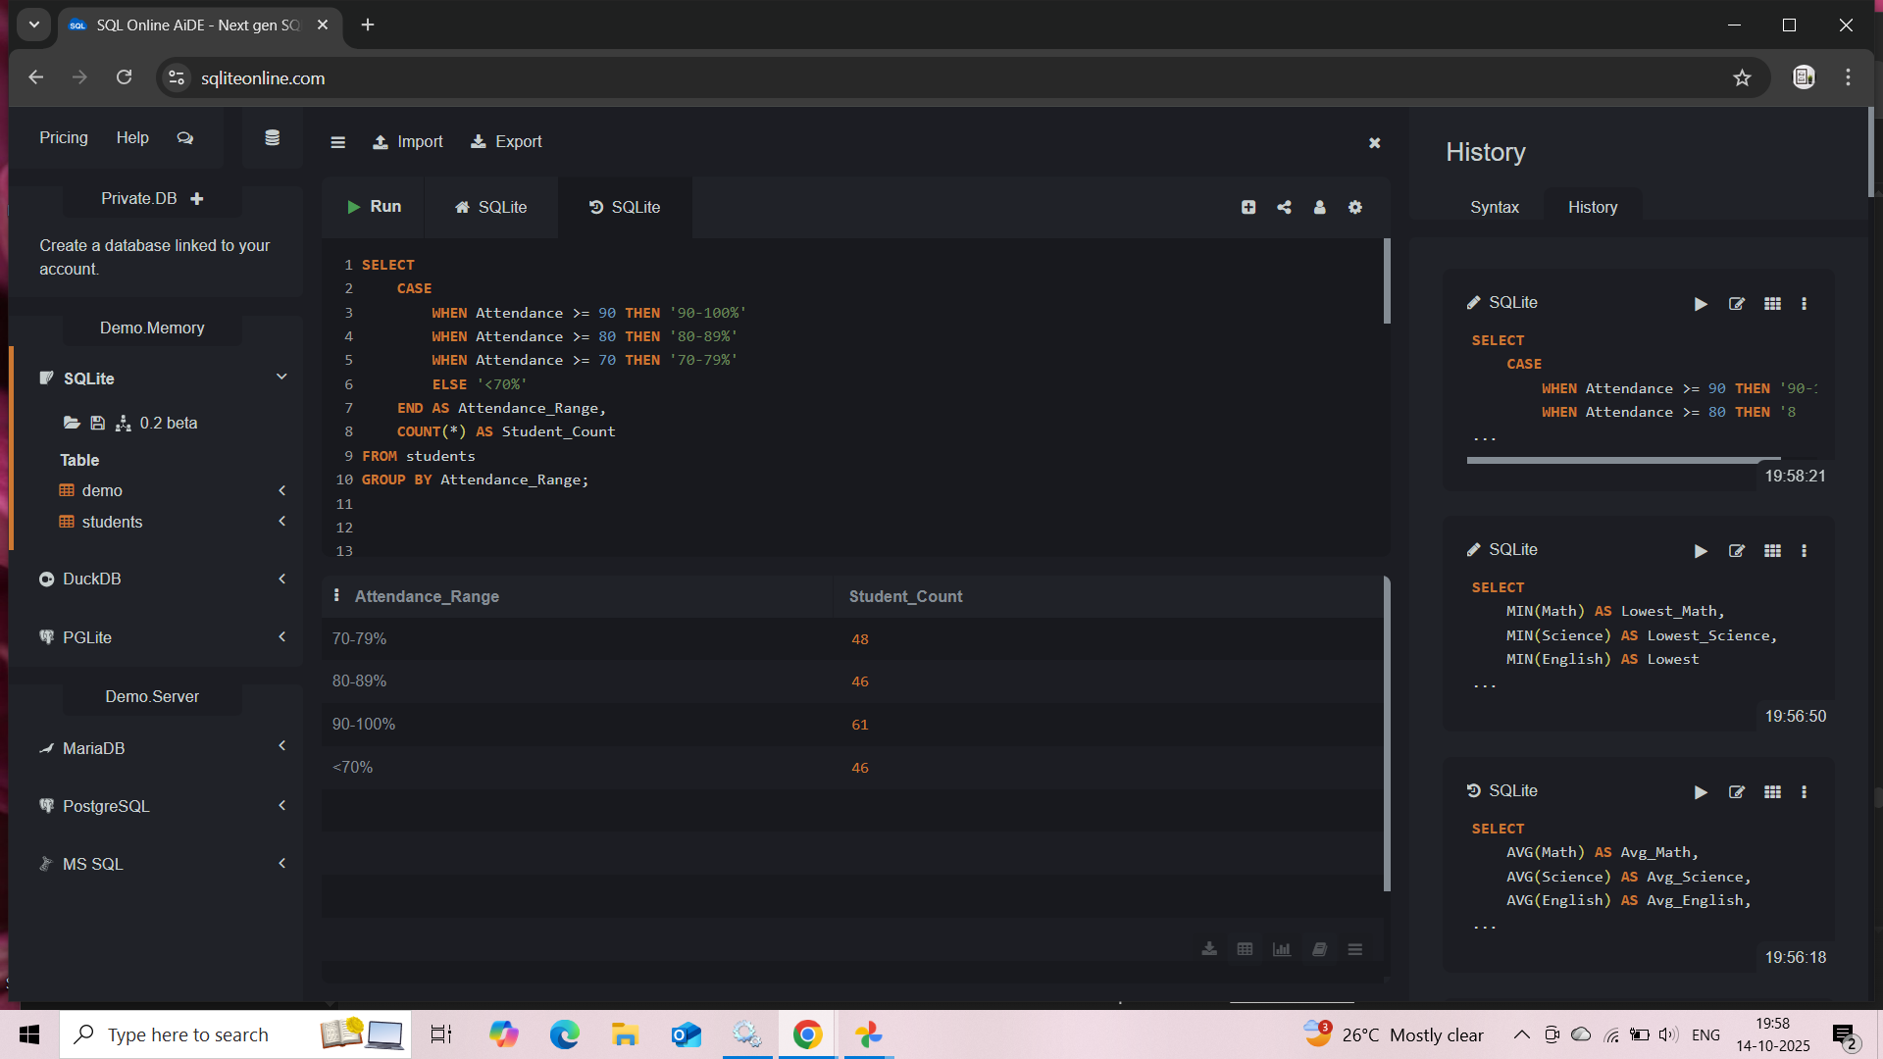

- GROUP BY:
Average marks by gender:
SELECT Gender, AVG(AverageMarks) AS Avg_Marks
FROM students
GROUP BY Gender;

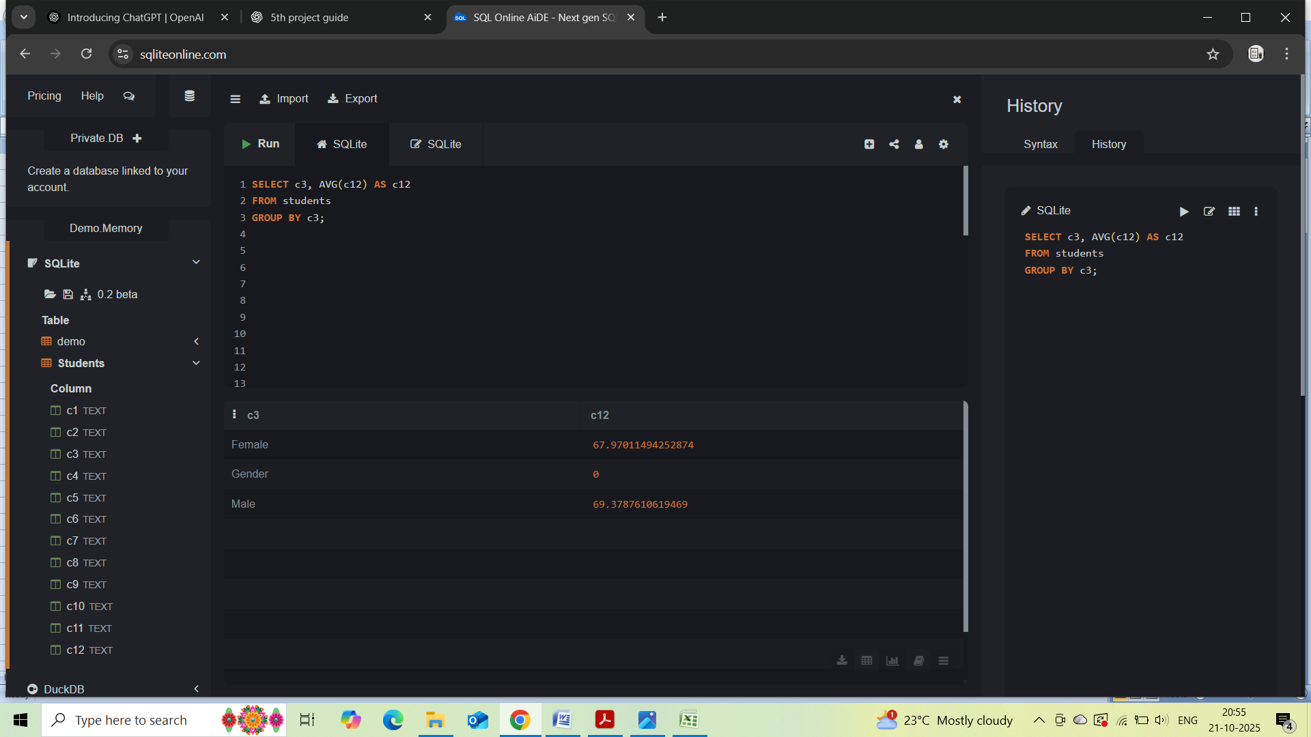

JOINS:
1.INNER JOIN:
Get only students who have matching records in both tables.
SELECT s.StudentID, s.Name, s.Class, m.TotalMarks, m.AverageMarks
FROM Student Info s
INNER JOIN Marks Info m
ON s.StudentID = m.StudentID;

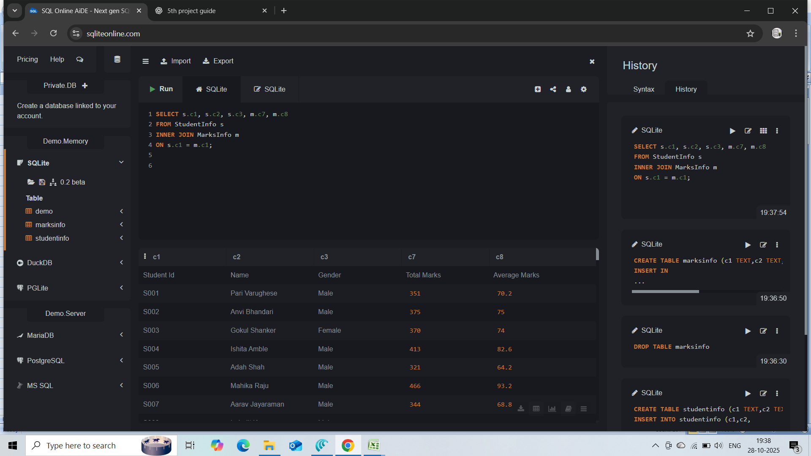

2.LEFT JOIN:
Get all students, even if marks are missing.
SELECT s.StudentID, s.Name, m.TotalMarks, m.AverageMarks
FROM StudentInfo s
LEFT JOIN MarksInfo m
ON s.StudentID = m.StudentID;

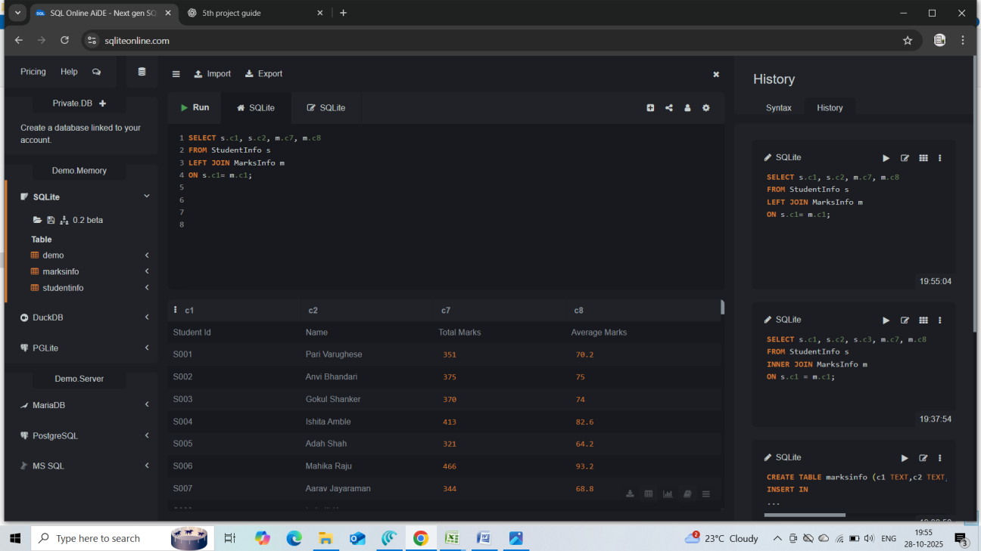
3. JOIN with WHERE:
Show students who scored more than 400 total marks.
SELECT s.Name, m.TotalMarks
FROM StudentInfo s
INNER JOIN MarksInfo m
ON s.StudentID = m.StudentID
WHERE m.TotalMarks > 400;

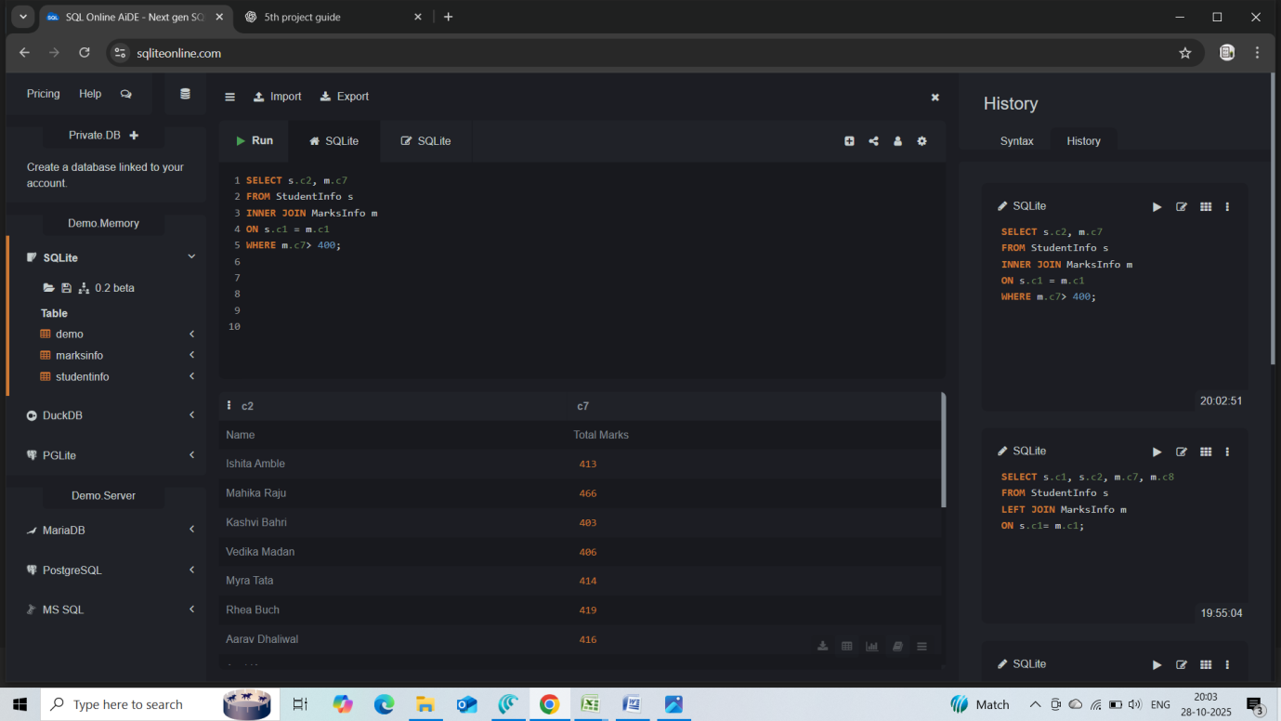

4. JOIN with ORDER BY:
Show top 5 students by marks.
SELECT s.Name, m.TotalMarks
FROM StudentInfo s
INNER JOIN MarksInfo m
ON s.StudentID = m.StudentID
ORDER BY m.TotalMarks DESC
LIMIT 10;

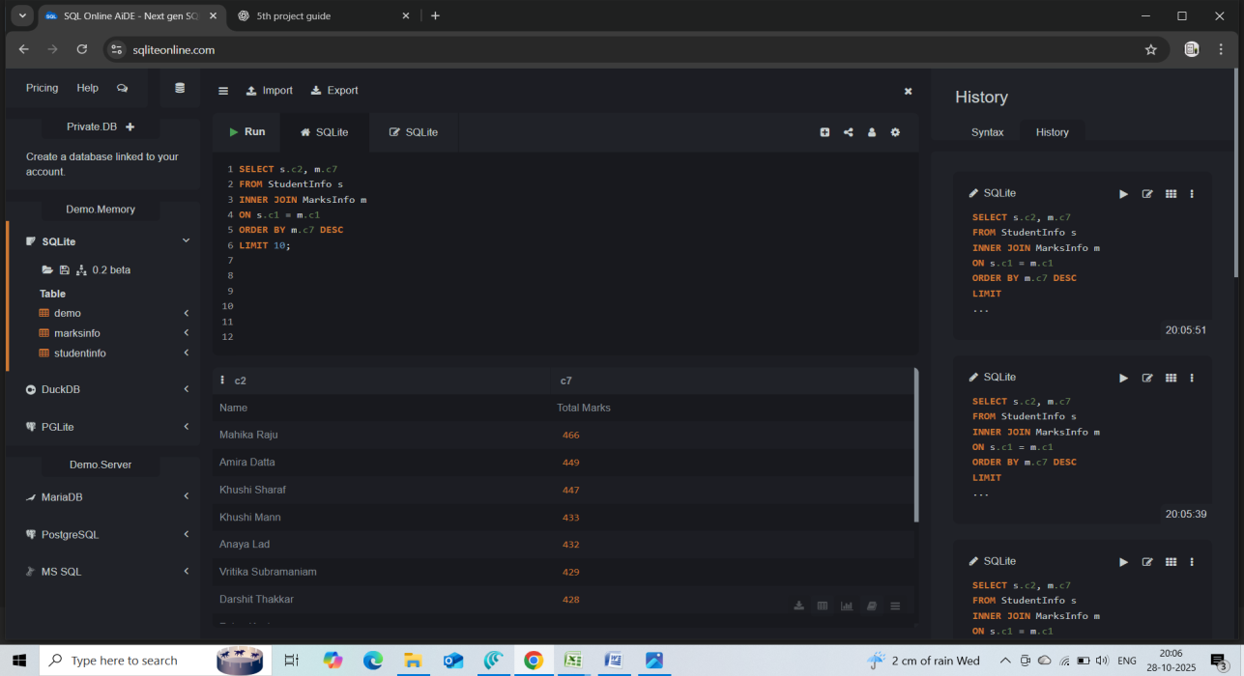
5. JOIN with GROUP BY:
Find average marks by gender.
SELECT s.Gender, AVG(m.AverageMarks) AS Avg_Marks_By_Gender
FROM StudentInfo s
INNER JOIN MarksInfo m
ON s.StudentID = m.StudentID
GROUP BY s.Gender;

